Task 2
the aim of this project is to develop a Python program for managing data related to hotdog vendors. The program uses data stored in a text file and allows the user to search, sort, validate and analyse vendor information through a menu-driven interface.
The program is designed using computational thinking skills such as decomposition and algorithm design. Different searching and sorting algorithms are implemented, including linear search, binary search, bubble sort and quick sort. Validation is also included to ensure that the data matches the required formats.
Additional features are added to improve the usefulness of the program, such as vendor analysis and the ability to save analysis results to an external text file.
Planning and Decomposition
The program was planned by decomposing the problem into smaller sections that could be developed individually. This made the project easier to manage and allowed each feature to be tested separately before being integrated into the final program.
The first section focused on file handling. The vendor data is stored in a text file and needed to be loaded into a two-dimensional array structure so that each vendor record and field could be accessed efficiently.
The next section focused on the user interface. A menu-driven interface was designed to allow the user to navigate the program and select different features such as sorting, searching, validation and analysis. I programmed this in the same version as file handling, which was V1.
The sorting functionality was then separated into two algorithms: bubble sort and quick sort. Bubble sort was implemented because it is simple to understand and useful for comparison, while quick sort was implemented because it is significantly more efficient on larger datasets.
Searching functionality was also decomposed into two separate algorithms. Linear search was used because it works on unsorted data, while binary search was implemented for sorted data to improve efficiency.
Validation was developed as a separate component to ensure that data stored in the dataset matched the required formats. This included checking vendor IDs, numerical values and formatting rules.
The final section focused on analysis features. These features calculate useful information from the dataset, such as the most productive vendor, total vegan and meat hotdogs supplied, and the vendor using the least ketchup. The results are also saved to an external text file.
Development process
During development, the program was built feature by feature so that each section could be tested individually before being integrated into the final system. This made debugging easier and allowed problems to be identified earlier in development. The program was developed using Python and organised into subroutines to improve readability and maintainability.
File handling
The first feature I implemented was file handling. The program reads vendor data from the Hotdogs.txt file and stores it in a two-dimensional array. Each line of the text file is split using commas so that each field can be stored separately within the array structure.
I chose a 2D array for this as it allows the program to store multiple vendor records while making individual fields accessible through indexing. This structure made sorting and searching more complex than the original subroutines. For example, I had to alter my binary search to search through an individual column rather than the entire array otherwise it would not work. However, this structure made the validation features easier to implement later in the program.
During development, it was important to ensure that the file was properly closed after reading data to avoid unnecessary resource usage.
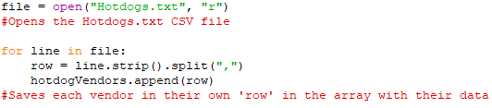
User Interface
A menu-driven interface was developed to allow the user to interact with the program. The interface repeatedly displays a list of options until the user chooses to exit the program. Match-case selection statements were used to process different menu options and direct the user to the correct functionality.
Validation was added to ensure that invalid menu choices could not be processed. This reduced the likelihood of runtime errors caused by unexpected input values.
One issue encountered during development was validating numerical menu input while still allowing the match-case structure to function correctly. This was solved by validating the input before converting it into an integer.
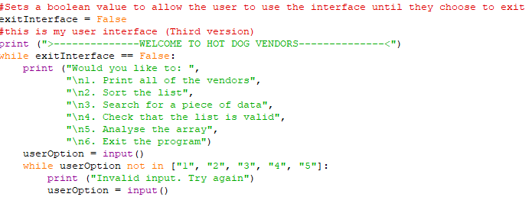
Sorting algorithms
Two sorting algorithms were implemented within the program: bubble sort and quick sort. These algorithms allow the user to organise vendor data by different fields such as vendor ID, vendor name, vegan hotdogs supplied and ketchup usage. Before I implemented these algorithms, I first created them in a separate python file with their own ‘test’ arrays to ensure they worked before adding them to the main program. This caused a problem for me later in the development process, as when I tested all of the features of the UI, the searches did not work since they were designed for a 1D array instead of a 2D array that is used in my main program. To deal with this, each of the sorts had to be altered with a separate ‘column’ value, which chose the column to sort by. This also meant that they needed another parameter to determine what data the user wants to sort by, so I had to add another section to the UI which asked the user what data they wanted to sort by, and then used their choice as an integer argument for the sorting algorithms.
Bubble sort was implemented first because it is straightforward to understand and simple to test. The algorithm repeatedly compares adjacent values and swaps them if they are in the wrong order. This process repeats until the entire dataset is sorted. Although bubble sort is less efficient on larger datasets, it was useful for comparison purposes and helped demonstrate understanding of iterative sorting algorithms.
Quick sort was also implemented because it is significantly more efficient than bubble sort when processing larger datasets. The algorithm works by selecting a pivot value and separating values into smaller groups based on whether they are less than or greater than the pivot. These smaller groups are then sorted recursively before being combined into a final sorted list.
One problem encountered during development was ensuring that the quick sort algorithm correctly returned the sorted data to the main program. Initially, the sorted values were not being stored correctly, which caused the original dataset to remain unchanged. This was resolved by storing the returned sorted array in a variable before displaying the results.
The sorting algorithms were developed as separate subroutines to improve readability and support separation of concerns. This also made testing easier because each algorithm could be tested independently.

Searching Algorithms
Two searching algorithms were implemented within the program: linear search and binary search. These algorithms allow the user to locate specific vendor data within the dataset.
Linear search was implemented because it is capable of searching unsorted data. The algorithm works by checking each record individually until the required value is found. This method is simple to implement and reliable for smaller datasets, although it becomes less efficient as the size of the dataset increases.
Binary search was also implemented to improve efficiency when searching sorted data. The algorithm repeatedly checks the middle value of the dataset and removes half of the remaining search area during each iteration. This significantly reduces the number of comparisons required compared to linear search.
Both searching algorithms were initially developed and tested within a separate Python test file before being integrated into the main program. The original algorithms were designed for one-dimensional arrays, so they needed to be adapted to work with the two-dimensional vendor dataset used in the final solution. Additional indexing was added so that specific columns within each vendor record could be searched correctly.
Although linear search did not strictly require adaptation to work with two-dimensional arrays, it was modified similarly to binary search to improve consistency and fairness when comparing the algorithms. Both algorithms therefore search data using the same column-based structure.
One issue encountered during development was that binary search only works correctly when data is already sorted. To solve this problem, checks were added to ensure that the user sorted the dataset before attempting a binary search.
The searching algorithms were developed as separate subroutines to improve readability and allow each algorithm to be tested independently.
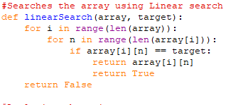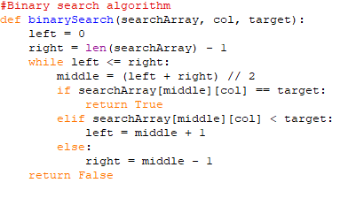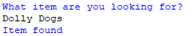

Validation
Validation was implemented to improve the robustness of the program and ensure that vendor data matched the required formats described within the assignment brief. Separate validation checks were created for each field in the dataset, including vendor IDs, vendor names, year and week values, hotdog quantities, onion weights and ketchup volumes.
Different validation techniques were used depending on the data type being checked. These included checking string lengths, verifying numerical ranges, checking for alphabetic and numeric characters, and ensuring that values followed the required formatting rules.
Input validation was also added to the menu system to reduce the likelihood of invalid menu choices causing runtime errors. This improved the reliability of the interface and prevented unintended behaviour during execution.
One issue encountered during development involved converting invalid input values into integers before validation had taken place, which caused runtime errors. This problem was reduced by validating input before processing it further.
Validation was developed as a separate subroutine to improve maintainability and support separation of concerns within the overall system.
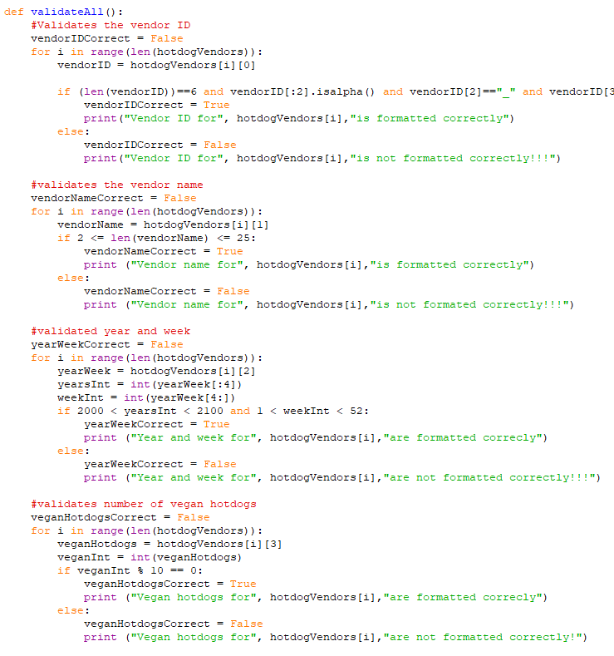
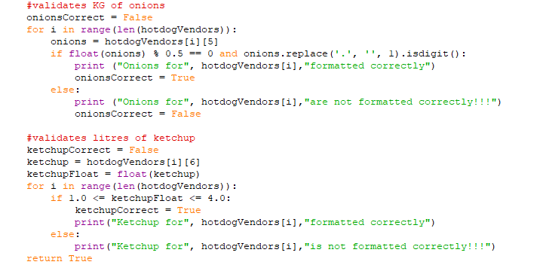
Analysis Features
Analysis functionality was added to provide useful information about the vendor dataset beyond simple searching and sorting. The analysis section calculates values such as the most productive vendor, the total number of vegan and meat hotdogs supplied, and the vendor using the least amount of ketchup.
The analysis feature was implemented using iteration and accumulation techniques. Variables were used to track totals and compare records while looping through the dataset. This allowed the program to identify maximum and minimum values efficiently.
The analysis results are displayed to the user through the interface and can also be saved to an external text file. File writing functionality was implemented so that the generated analysis could be stored and accessed later.
One issue encountered during development was ensuring that numerical values were correctly converted from strings before calculations were performed. This was solved by converting the required fields into integers and floating-point values during processing.
The analysis functionality improved the usefulness of the program and helped meet the requirement for data analysis stated within the assignment brief.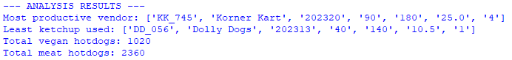
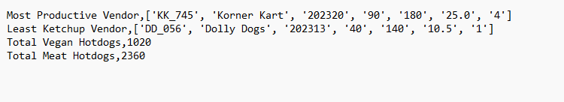

Good Programming Practices
Several good programming practices were used throughout development to improve the readability, maintainability and reliability of the program. Meaningful variable names were used to make the purpose of variables easier to understand, while comments and whitespace were included to improve code readability.
The program was organised into multiple subroutines, including separate functions for sorting, searching, validation and analysis. This supported separation of concerns and reduced unnecessary repetition within the code.
Validation was implemented to improve robustness and reduce the likelihood of invalid data causing runtime errors. In addition, algorithms were tested individually before integration into the final program to help identify and correct problems earlier during development.
A systematic approach was used throughout development by implementing and testing one feature at a time before moving onto the next section of the program.

Unit Testing
Unit testing was carried out on individual subroutines to ensure that they produced the expected results. Testing individual components separately made it easier to identify faults during development and confirm that algorithms behaved correctly before integration into the final program.
Function Tested | Test Input | Expected Result | Actual Result | Outcome
Bubble sort | Unsorted vendor records | Records sorted correctly | Records sorted correctly | Pass
Binary search | Existing vendor ID | Item found | Item found

Additional testing was also carried out during development using invalid inputs and edge cases to improve reliability and robustness.

Milestones / Version Control
The project was developed incrementally through multiple versions. Features were implemented and tested individually before being combined into the final program. Saving milestone versions made it easier to recover earlier versions of the program and track progress during development.
Version 1: Implemented file handling, a basic menu driven interface, and the initial versions of sorting and searching algorithms.
Version 2: Improved functionality and structure of the User interface by adding additional menu options and improving navigation.
Version 3: Added validation for the vendor text file to ensure data matched the required formats.
Version 4: Adapted bubble sort and quick sort algorithms so they functioned correctly with 2D arrays rather than 1D lists.
Version 5: Adapted linear and binary search algorithms so they functioned correctly with 2D arrays rather than 1D lists.
Version 6: Implemented analysis features and added the ability to save analysis results to an external text file.
This is proof of the repository where I stored everything from my coursework.

This is proof of my archive, where all of my test programs and previous versions of the main program are saved
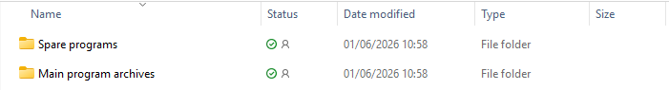

My main programs were all stored together in the main program versions folder.
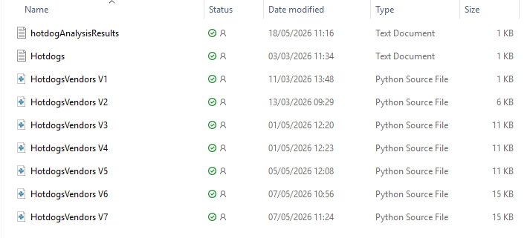

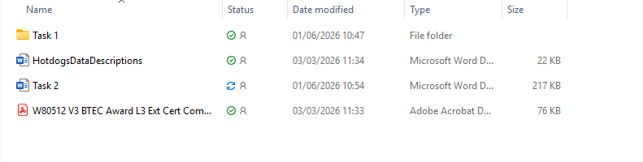
This is the folder that contains all of my word documents, including a folder for task 1, the provided HotDogsDataDescriptions word file, task 2 word file and the exam brief. The task 1 folder contains the task 1 final document, task 1 notes and my task 1 checklist.

At the end of each version, I added a timestamp to show the date and time that each version was completed.

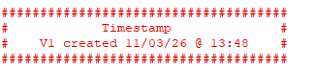

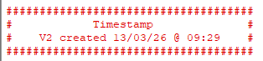

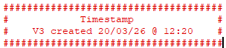

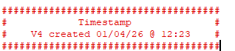

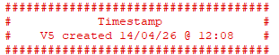

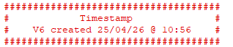

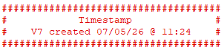

Linting
The Flake8 linter was used within Visual Studio Code to identify potential issues within the program code. Linting helped identify problems such as inconsistent formatting, unnecessary whitespace and readability issues.
Using Flake8 improved the overall quality and maintainability of the program by making the code more consistent and easier to understand.

Evaluation
Overall, the program successfully meets the majority of the requirements stated within the assignment brief. The final solution is capable of loading vendor data from an external text file, sorting and searching records using multiple algorithms, validating data formats, analysing vendor information and saving analysis results to an external file.
The use of multiple searching and sorting algorithms demonstrates understanding of algorithm design and computational thinking skills. Subroutines were used throughout the project to improve maintainability and support separation of concerns.
Some challenges were encountered during development, particularly when adapting algorithms originally designed for one-dimensional arrays so that they functioned correctly with two-dimensional data structures. Additional issues were also encountered with validation and ensuring that binary search only operated on sorted data. These issues were resolved through testing and iterative development.
If the project were developed further, additional features could be added such as editing vendor records directly within the program, improving the graphical interface and implementing more advanced data analysis functionality.

